1. HOME
2. SERVICES
3. ABOUT US
4. CONTACT US

**HOME**

We are providers of marine engineering services in Kochi. We are into building, repairing, and maintaining steel, aluminium, and FRP boats. We have the facility to construct and repair various types of vessels up to 55 meters x 10 meters.

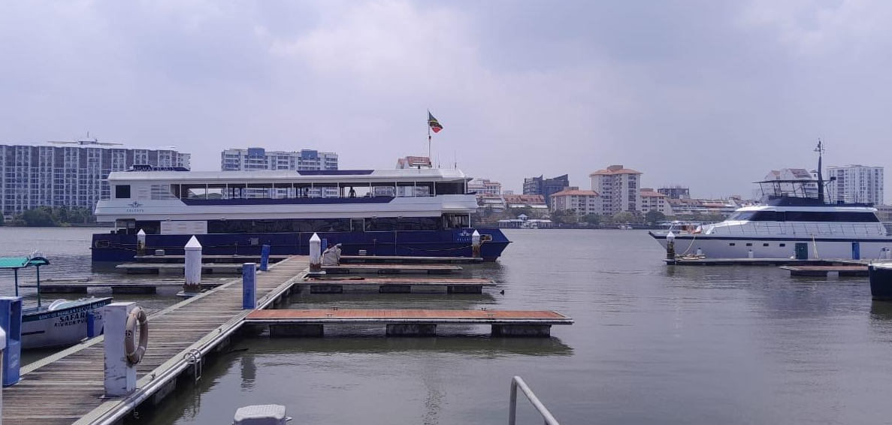

**About US**

**We are pleased to introduce Dhariya Marine Engineering Services to your organization as providers of marine engineering services.**

**Our boatyard is situated in Kochi which has a facility for building and repair. This facility having work approvals from the Kerala Maritime Board, Govt. of Kerala, is capable of undertaking the construction and repair of various types of vessels up to 55 meters x 10 meters in size at present and is in the process of expanding the capacities further.**

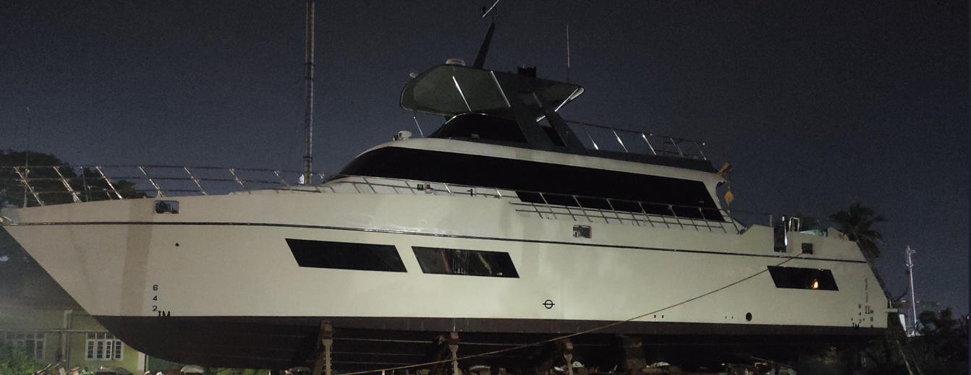

**OUR SERVICES**

Building

* Barge and Boat Building works in steel, marine-grade aluminum, and GRP.
* Grit blasting and painting works
* Installation of marine engines, electric motors, batteries, and OBM
* Installation of pumps, motors, windlasses, cranes, bow thrusters, etc.
* Installation of propeller, shaft, rudder, and steering works
* Installation of generators, batteries, solar, and BMS systems.
* Electrical cabling and termination work
* Bilge, fire, fuel, sewage, and ballast pipeline and valve works
* Vessel accommodation works, glazing works, etc.

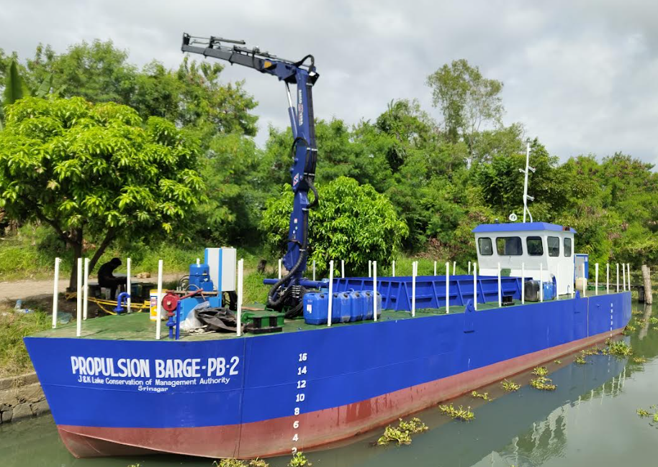 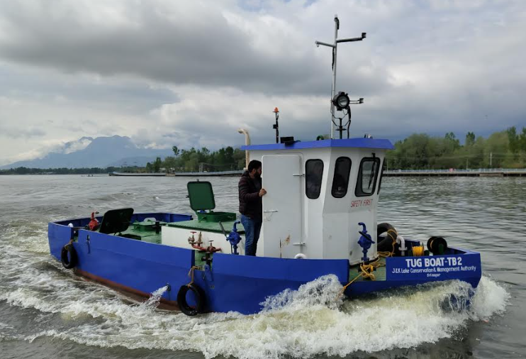 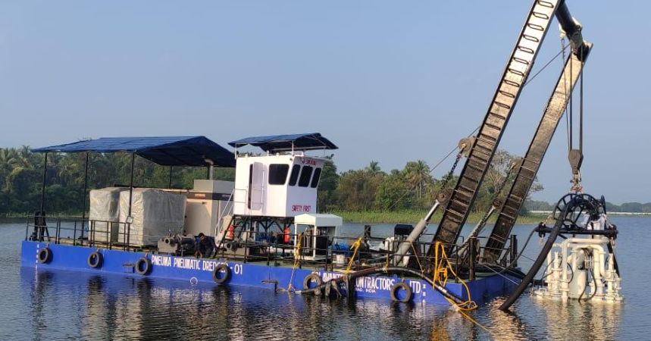

Repair

* IRS, KIV annual survey, shaft survey, drydock survey works
* Docking and undocking of vessels
* Rebuilding and restoration of crafts
* Grit blasting and painting works
* Steel and aluminum repair works
* Wood, fiberglass vessel repair
* Interior woodwork
* Propeller, shaft, rudder, steering works
* Overhauling/servicing of marine engines, outboard motors, and gearboxes
* Overhauling of valves, pumps, motors, winches, and windlasses
* Hydraulic, bilge, ballast, cargo, fuel, and seawater freshwater pipeline renewal works
* Marine electrical cabling and termination work
* Machining jobs
* Underwater diving works—In-water survey
* Hydraulic works
* Spare supply
* Upholstery and boat cover works
* 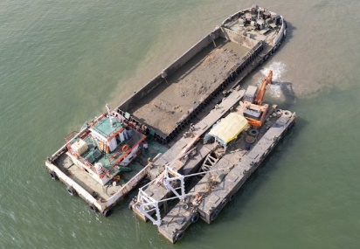 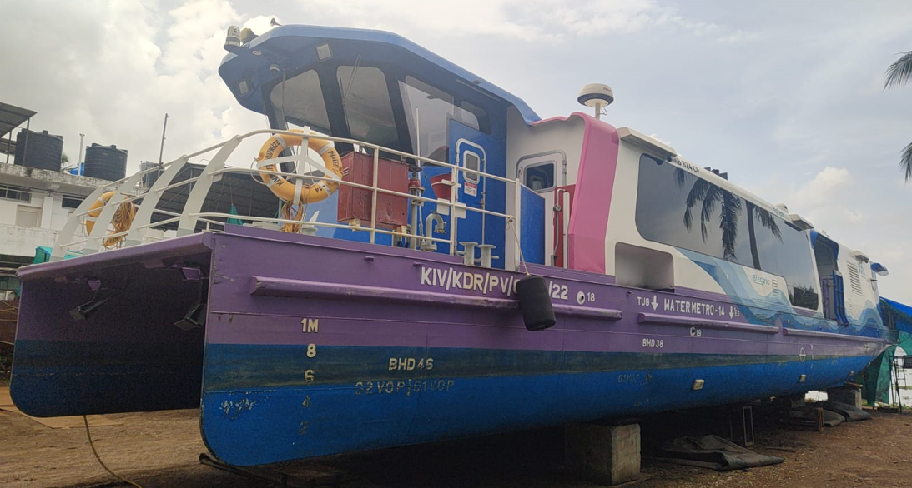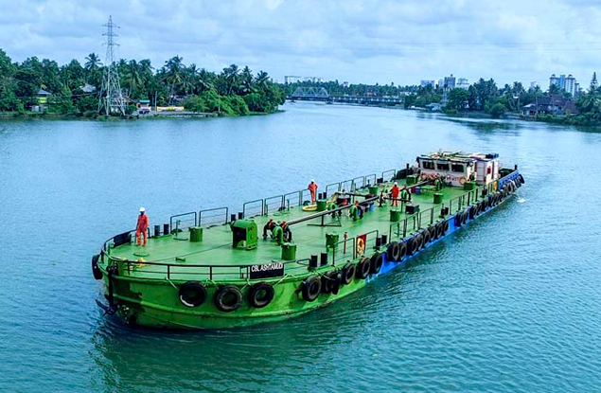 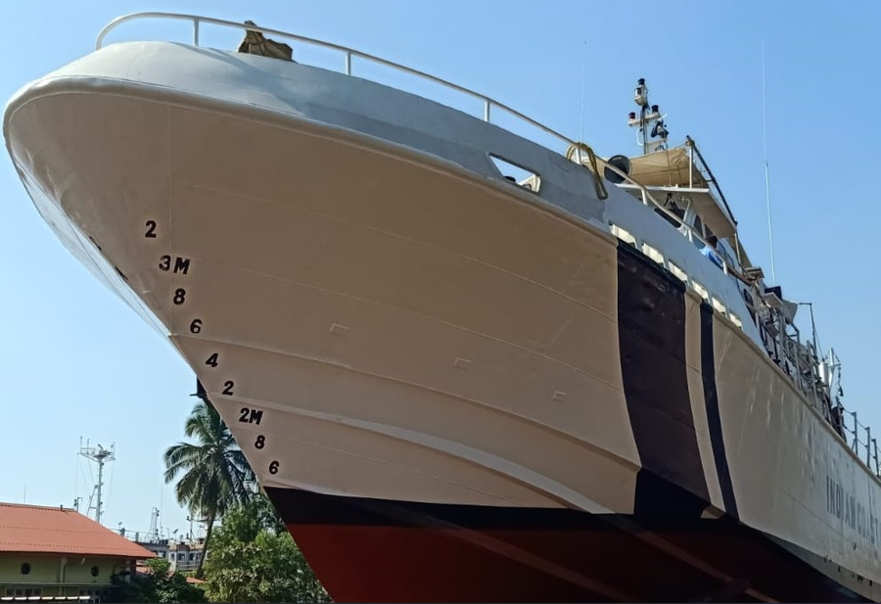

Launching air bags

Hauling up and launching of vessel of size 55 meters x 10 meters—Tonnage: 500 tons

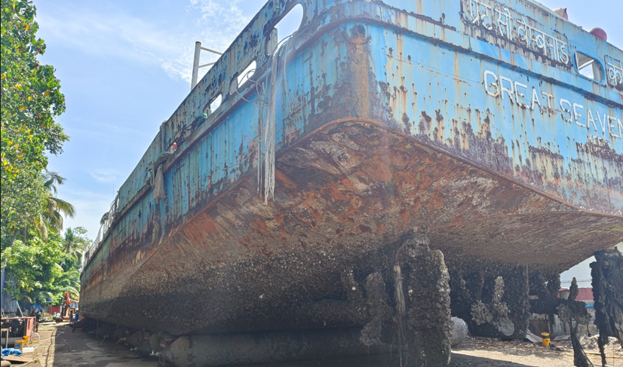 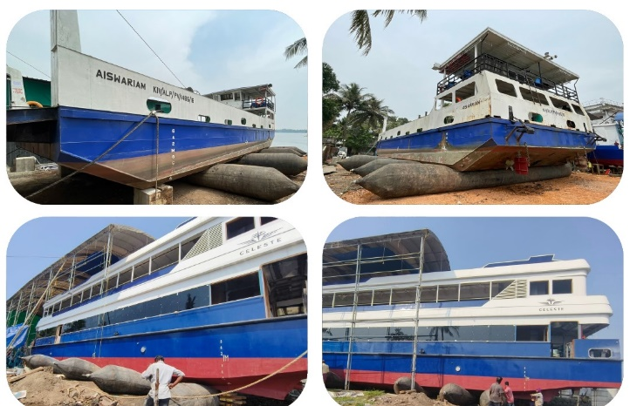

Plastic welding

* Extrusions and hot air hand welders using sheets from 4mm to 50mm
* Custom-made plastic tanks—tanks made from thermoplastics such as HDPE and PP

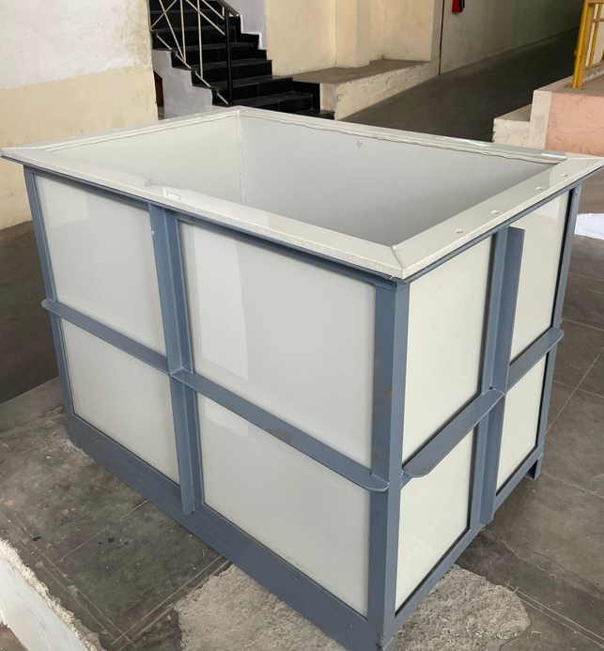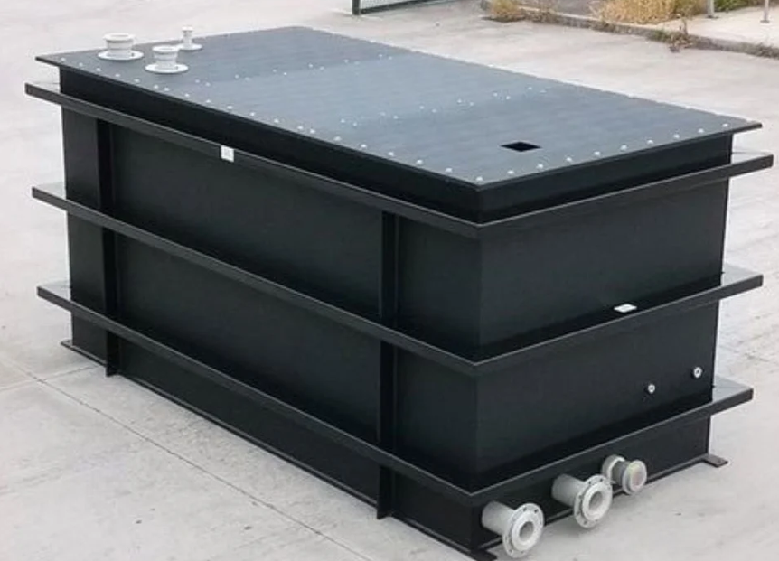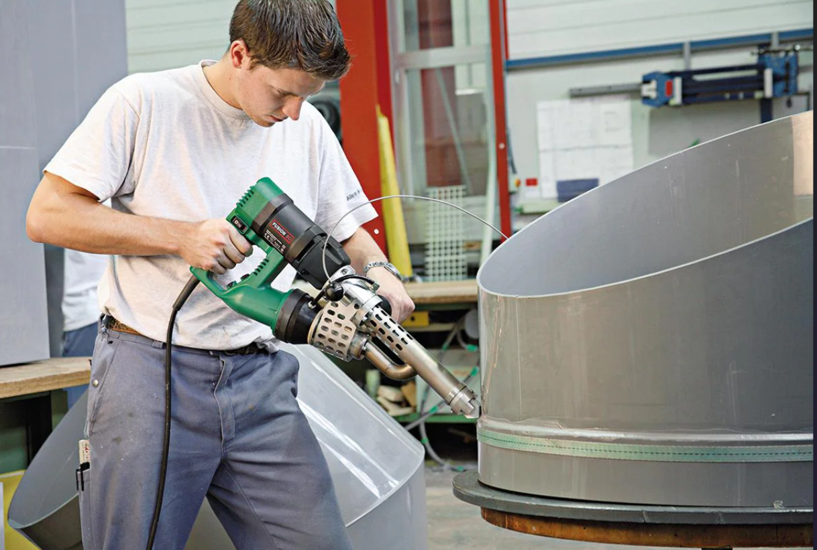



PIN NUMBER - 682010

MAPS – AVAILABLE IN GOOGLE

